Avoyelles Public Charter School

Sponsorship Program

* Invest in the future of children
* Contribute to the success of APCS and its’ extra-curricular programs
* Ads reach customers throughout Avoyelles Parish and surrounding parishes
* Tax write-off
* Season Passes for Athletics**
* Tickets to school productions**

**Admission to games and plays will be contingent on protocol at that time. If circumstances arise that are out of our control, we might not be able to honor sponsor passes and tickets.

Along with the Sponsorship Program, there are many other ways to support APCS. If you are not interested in a sponsorship at this time, but would like to help, call 318-240-9991 and we will give you more information.

**APCS Sponsorship Form**

**Deadline: October 17, 2022**

**Membership Levels:**

**Please check one**

_____VIP Level $1000.00 or more

_____Elite Level $500.00-$999.00

_____Select Level $300.00-$499.00

**Contact Information**

Business Name or Family Name:

**___________________________________**

Mailing Address:

________________________________

________________________________

Contact Person:____________________

Email:____________________________

Oldest APCS child’s name/grade:

_________________________/________

(If Applicable)

Phone #:_________________________

Check No. _______ Amount $________

Make checks payable to APCS and mail to address listed on the front.

**Note: We will accept memberships after the deadline, but we will not be able to run your ad in programs printed prior to receipt of your application.**

**Avoyelles Public Charter School 201 Longfellow Road Mansura, La. 71350 Phone (318) 240-9991 Fax (318)253-4198 Website: apcs.us Email: ginabertalotto@apcs.us**

C:\Documents and Settings\APCS Faculty\Local Settings\Temporary Internet Files\Content.IE5\EH54C32C\MC900015063[1].wmf

**Avoyelles Public Charter School**

**Sponsorship Program**

**2022-2023**

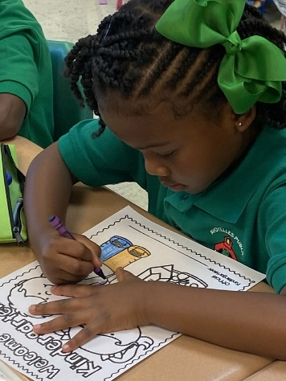

**\*VIP Membership Package**

* Full page ad in all school programs produced by APCS
* Recognition at APCS Sponsor Night
* Gift of appreciation to be displayed at your place of business or home
* 4 Athletic Season Passes good for all regular season home games **
* 4 tickets for each production **
* 4x8 foot sign placed on the baseball or softball or renewal of existing sign 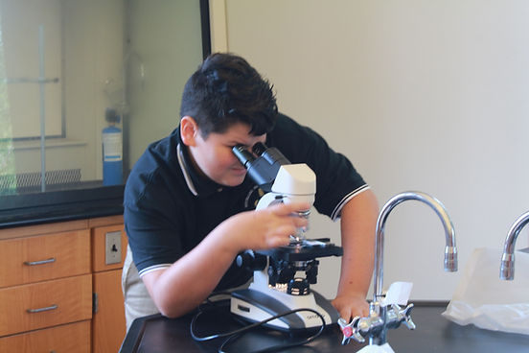

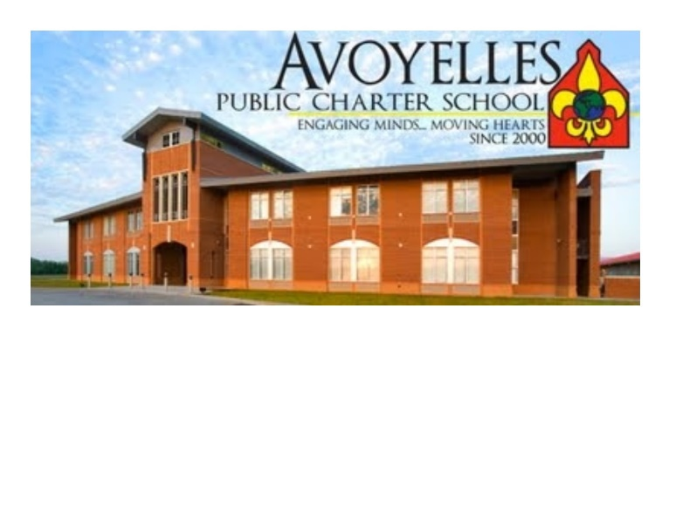

**\*Elite Membership Package**

* Half page ad in all school programs produced by APCS
* Recognition at APCS Sponsor Night
* Gift of appreciation to be displayed at your place of business or home
* 2 Athletic Season Passes good for all regular season home games **
* 2 tickets for each production **

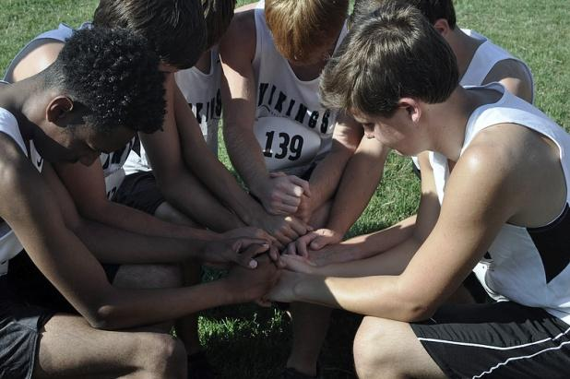

\***Select Membership Package**

* ¼ page ad in all school programs produced by APCS
* Recognition at APCS Sponsor Night
* Gift of appreciation to be displayed at your place of business or home
* 2 Athletic Season Passes good for all regular season home games **
* 2 tickets for each production **

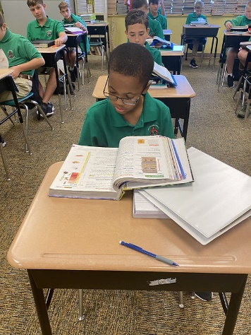

If you have any questions, concerns, or suggestions, email [ginabertalotto@apcs.us](mailto:ginabertalotto@apcs.us).

Thank you for your time and consideration.